Name of the Student: G. Manasa Goud | Academic Year: 2025-28
Student Registration Number: 241U1R3007 | Year & Term: II & II
Study Level: UG | Class & Section: CSE DS 2A
Name of the Course: Foundations of Data Science | Name of the Instructor: Mr. Pranay Vemula
Name of the Assessment: Group Assignment | Date of Submission: 13-12-2025

Group Assignment

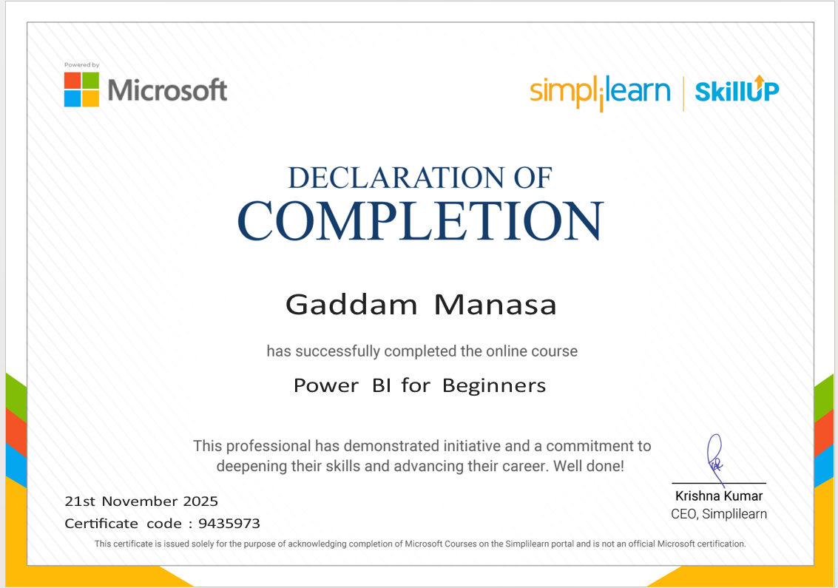

This Power BI Basics course from Simplilearn SkillUp is a free beginner course. It explains what Power BI is and how it is used to turn data into charts, reports, and dashboards. The course is easy to understand and is useful for students who are new to data analysis.

What I Learned from This Course
From this course, I learned that Power BI is a powerful tool for analyzing and visualizing data. I understood how data from different sources can be imported, cleaned, and transformed into useful information. This course helped me learn how to use Power BI Desktop to create reports and understand the importance of data modeling and relationships between tables. I learned the basic use of DAX formulas to perform calculations and how to create interactive dashboards using charts, slicers, and filters. Through visual reports, I understood how data can be analyzed easily for better decision-making. Overall, this course helped me understand how businesses use Power BI to analyze data trends, track performance, and present information clearly.

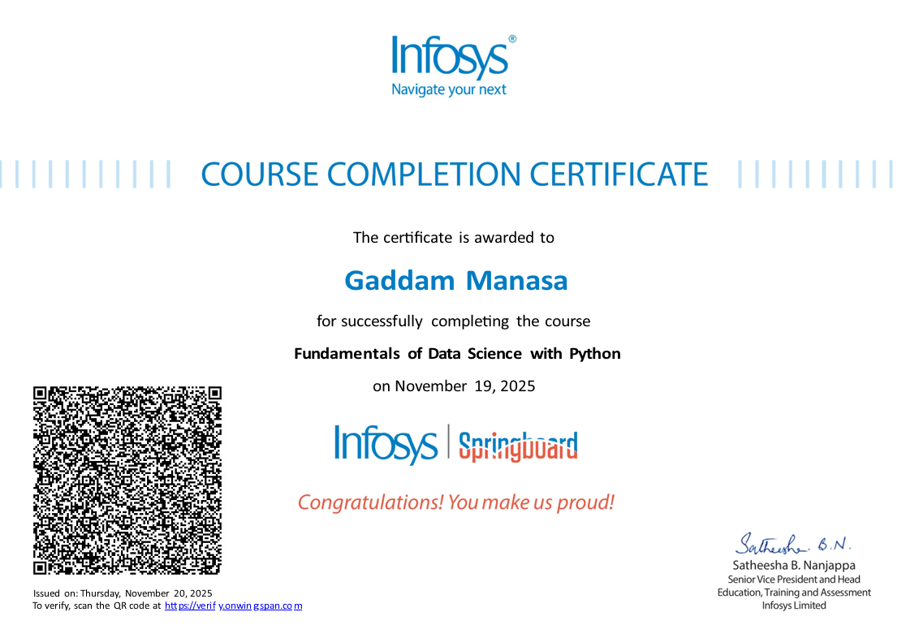

This course from Infosys Springboard gives a basic introduction to Data Science. It starts from the fundamentals and slowly moves to advanced topics like statistics, visualization, and machine learning. The course helps students understand how data is collected, processed, analyzed, and used to make decisions.
The course starts with a Primer on Python, where basic Python concepts are taught in an easy way for beginners. Then, Python for Data Science explains how Python is used to work with and analyze data.
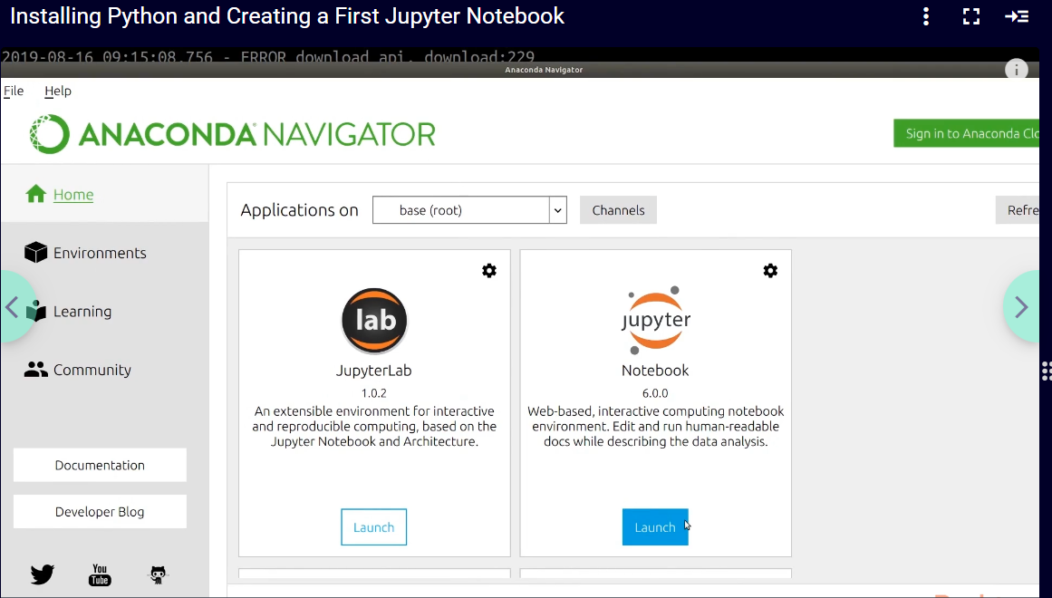
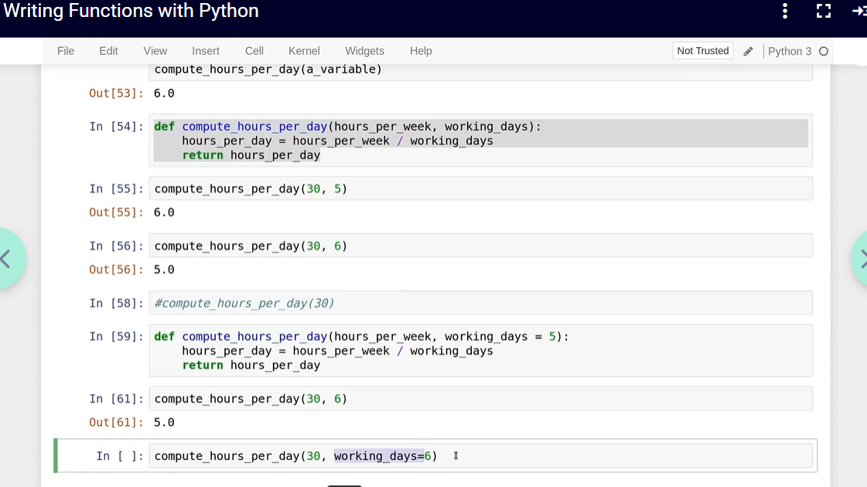
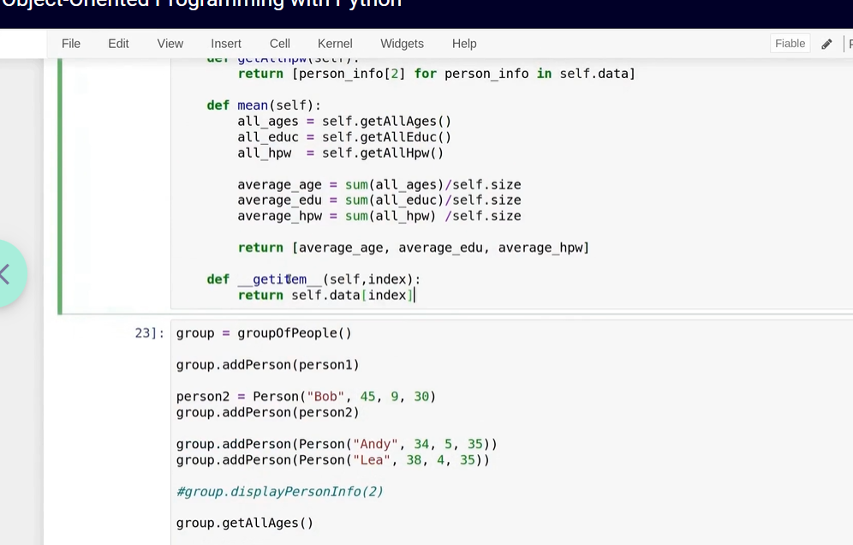
After that, Getting Your Dataset Ready for Processing teaches how to clean and prepare data before using it. The How Visualizations Work section explains how charts and graphs help us understand data clearly.
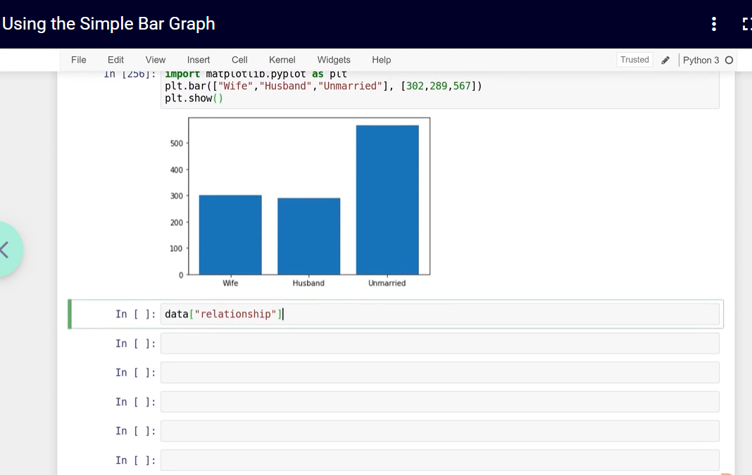
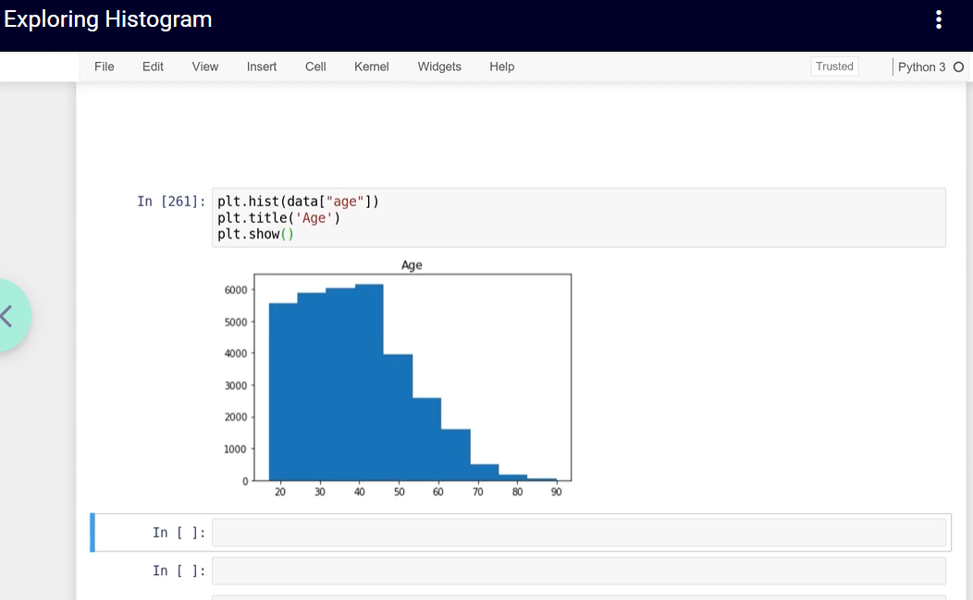
The course also covers Statistics and Probability, which help in understanding data patterns. In Statistical Modelling and Fitting, we learn how to create simple models using data.
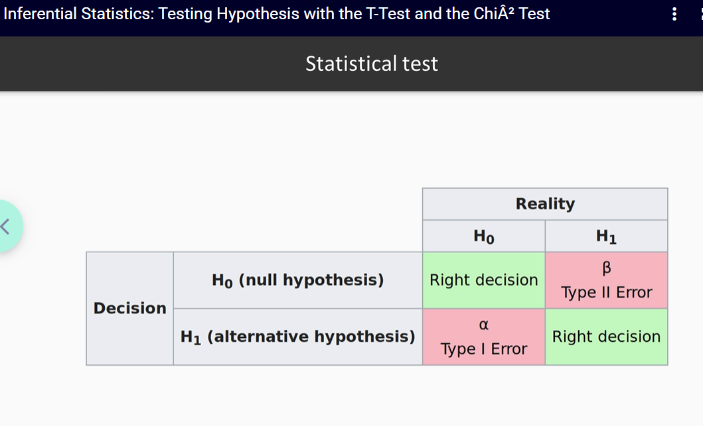
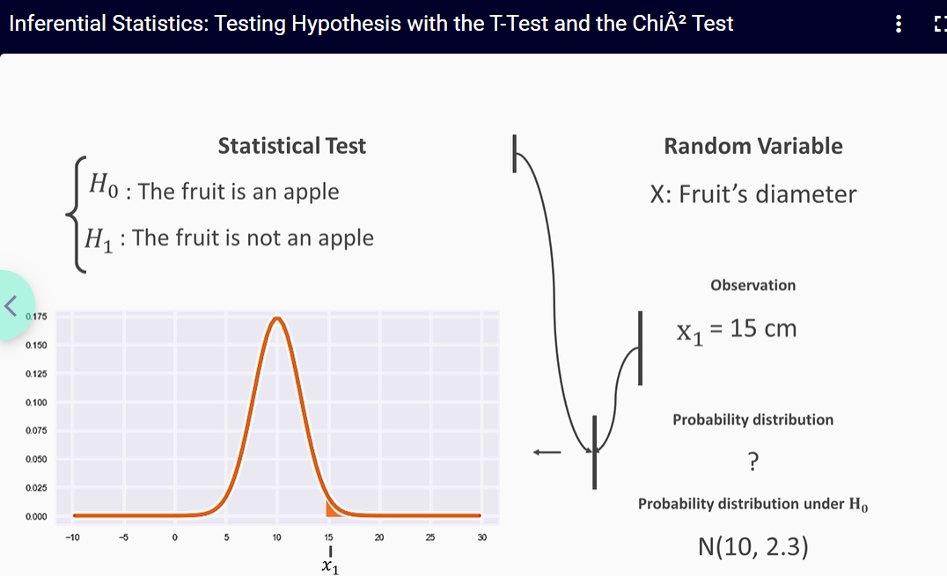

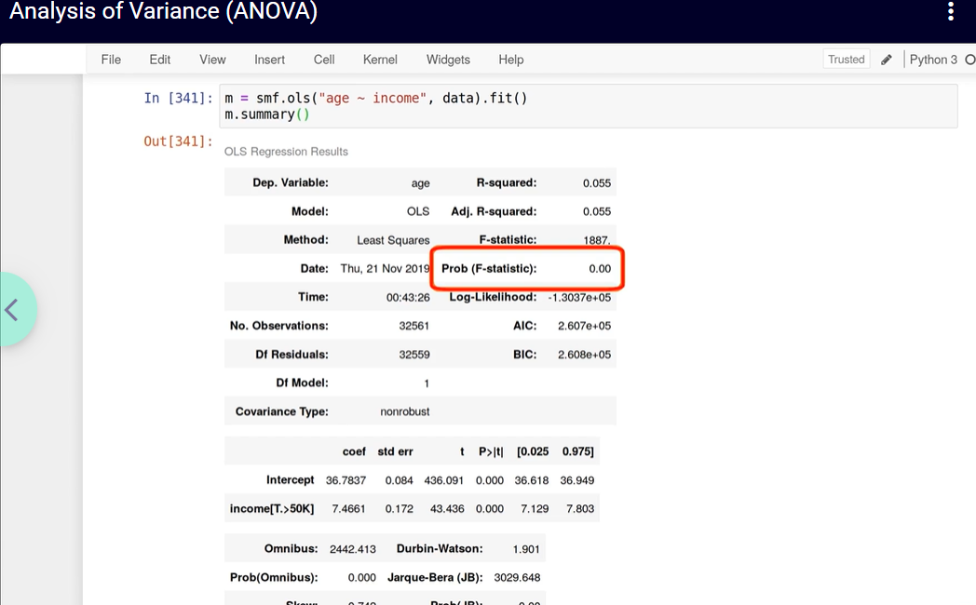
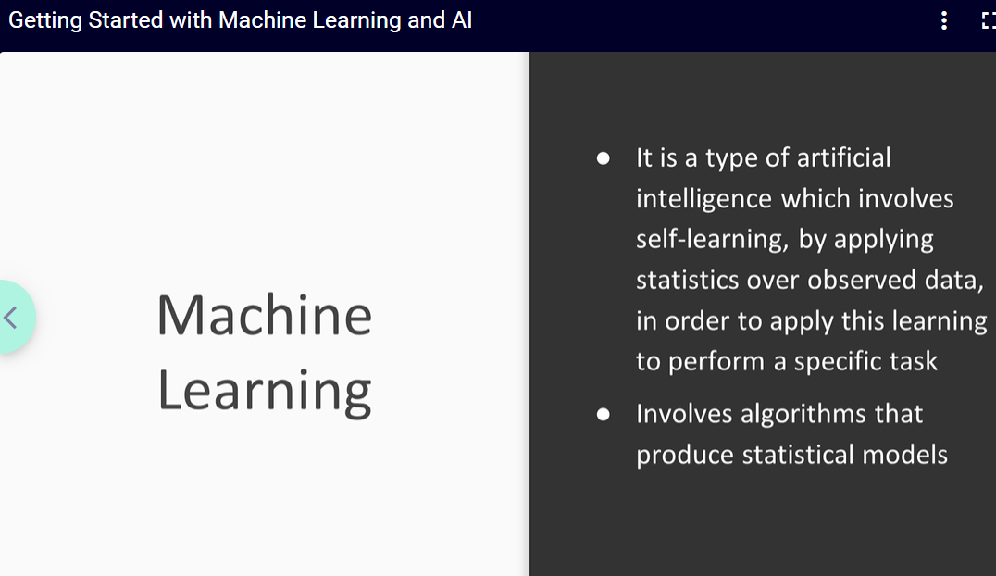
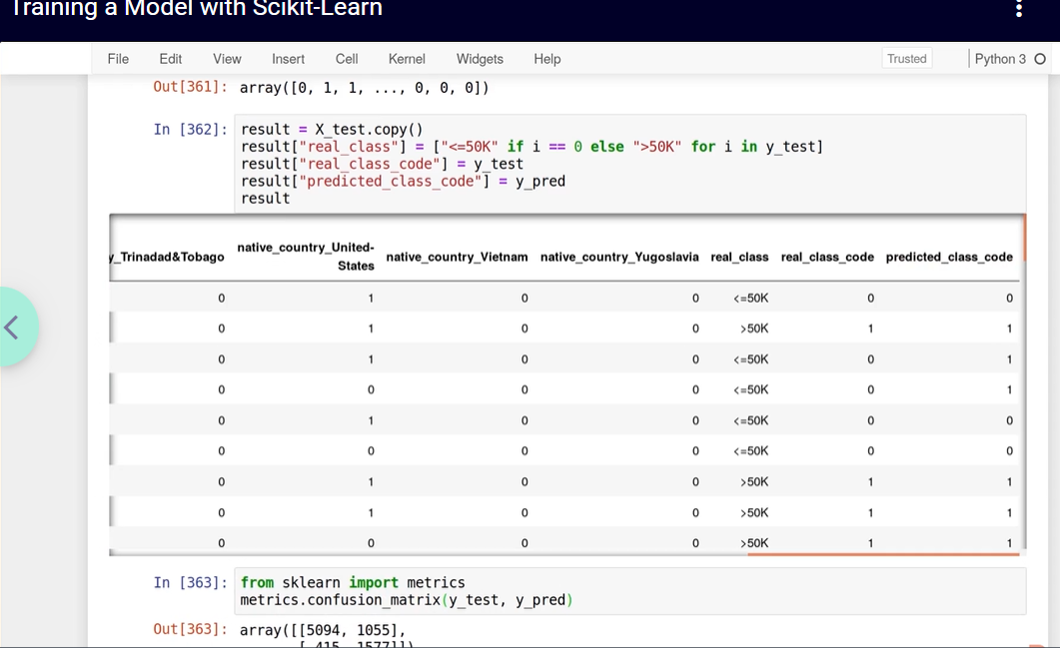

What I Learned from This Course
From this course, I learned the basics of Python, how to prepare and analyze data, and how visualizations make data easy to understand. I also learned basic statistics, modelling concepts, and an introduction to machine learning. This course helped me understand how data science is used to analyze data and support decision-making.

